**mpm-for-rodents installation and run on HPC**

**date: 12/14/23**

**CONTENTS**

**1) Download**

**2) Open HPC-frontend node via MobaXterm**

**3) Install ANTx2-toolbox**

**4) Install mpm-for-rodents-wrapper functions**

**5) Update antx2-toolbox and mpm_rodent-toolbox**

**6) Download template**

**7) Add ANTx-paths**

**8) Go to study-folder**

**9) Create an ANTx project-file**

**10) Load the project-file 'proj.m'**

**11) Check whether the project-file loaded**

**12) Import BRUKER-data**

**13) Visualize files and folders**

**14) Selection of animals (not needed now, but later)**

**15) Modify the ANTx-project file**

**16) Set path of mpm_rodent-toolbox**

**17) Create 'mpm'-dir & copy necessary files**

**18) Modify 'mpm_NIFTIparameters.xlsx'**

**19) Modify 'mpm_config.m'**

**20) Run all processing steps (interactive session)**

**21) SLURM SBATCH & non-interactive session**

**22) SLURM SBATCH & parallel processing**

**MISC-1: Other command snips**

**MISC-2: get pre-orientation from standard-space to T1/MT/PD-space**

**MISC-3: get pre-orientation from t2w-space to T1/MT/PD-space**

**1) Download**

**download MPM-installer**

Copy below link in web browser

<https://raw.githubusercontent.com/ChariteExpMri/mpm_rodent/master/updatempm.m>

save file as 'install_mpm.m' (via ctrl+s) to path where the mpm-wrapper functions should be installed

My path is 'X:\ressources' (windows-path to HPC-storage )

**download ANTx2-installer**

Copy below link in web browser

<https://raw.githubusercontent.com/ChariteExpMri/antx2/master/installfromgithub.m>

save file as 'installfromgithub.m' (via ctrl+s) to path where the ANTx2-tbx should be installed

My path is 'X:\ressources' (windows-path to HPC-storage )

**download hMRI-toolbox-0.2.4**

Please download the version **hMRI-toolbox-0.2.4** (this was the only version which was tested):

<https://github.com/hMRI-group/hMRI-toolbox/releases/tag/v0.2.4>

For more information of hMRI-toolbox see: <https://www.cbs.mpg.de/abteilungen/neurophysik/software/hmri-toolbox>

-Unzip folder and store it on your local path

**download a template from googledrive**

🡪 see information below

**2) Open HPC-frontend node via MobaXterm**

**OPEN INTERACTIVE JOB on HPC (optional)**

srun --time 24:00:00 --mem=64G --ntasks=8 --pty bash -i

-Please check the parameters, here for time 24h, 64 Gb Ram, 8 cores

**LOAD MATLAB-MODULE AND START MATLAB (optional)**

module load scientific/matlab/R2021b

matlab

-Note: The access to Matlab might be different on your machine!

The below fig shows the Matlab-console from HPC-interactive session

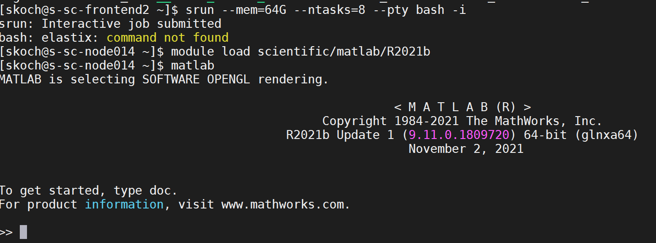

**3) Install ANTx2-toolbox**

-go to path where file **'installfromgithub.m'** was stored. Note, this path is used for installation of ANTx2

cd /sc-projects/sc-proj-agtiermrt/Daten-2/ressources/



Type the following to install antx2:

installfromgithub('install','path',pwd)

When successful, the antx2-folder is created:



-for further information how to install ANTx2 see: <https://chariteexpmri.github.io/antxdoc/docs/tutorial_noGraphic_support.pdf>

**4) Install mpm-for-rodents-wrapper functions**

-go to path where file '**install_mpm.m'** was stored. Note this path is used for installation of mpm-wrapper-functions

Type the following to install mpm-wrapper-functions:

install_mpm

When successful, the mpm_rodent-folder is created:

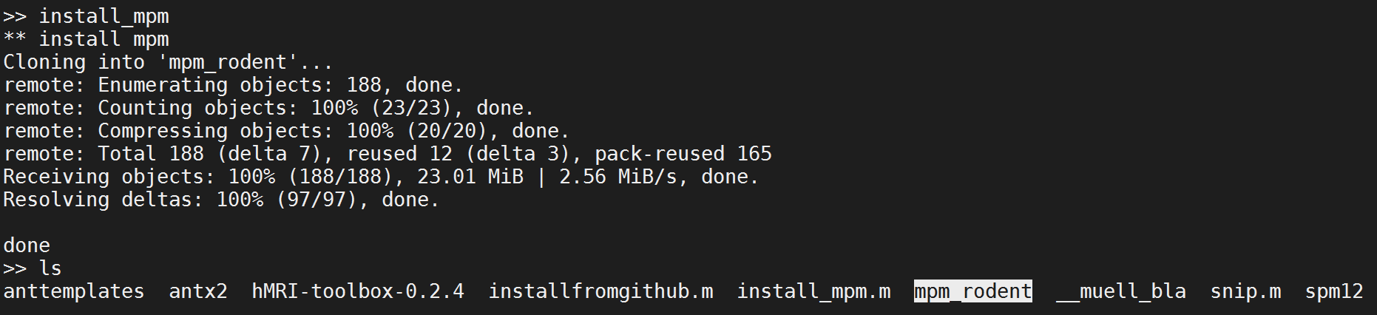

**5) Update antx2-toolbox and mpm_rodent-toolbox**

To update antx2 and the mpm_rodent-toolbox execute the following commands:

% *** UPTATE ANTx2 ***

cd antx2

updateantx(3)

cd ..

% *** UPTATE mpm_rodent-toolbox ***

cd mpm_rodent

updatempm(3)

cd ..

When done you should see the following:

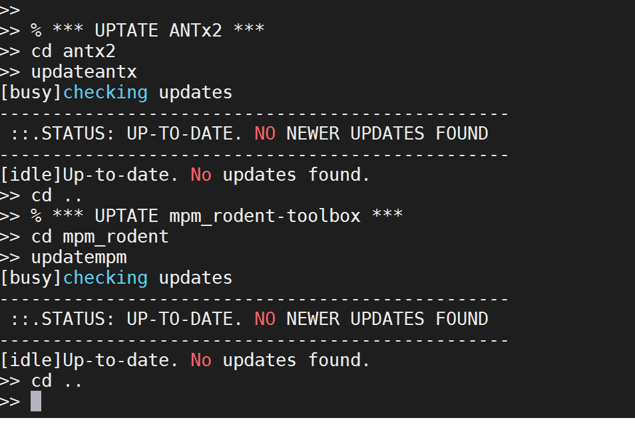

**6) Download template**

**Go to** [**https://drive.google.com/drive/u/0/folders/1q5XOOVLvUYLqYsQJLqNRF7OK8fNwYhI9**](https://drive.google.com/drive/u/0/folders/1q5XOOVLvUYLqYsQJLqNRF7OK8fNwYhI9)

And download the template '**mouse_Allen2017HikishimaLR'**

Create a new folder '**anttemplates**' at the same hierarchical level as the 'antx2'-folder

Unzip the 'mouse_Allen2017HikishimaLR.zip' and store it without subfolders in the anttemplates-folder

i.e.:

good: 'myPATH/ressources/**anttemplates/mouse_Allen2017HikishimaLR**'

bad: 'myPATH/ressources/**anttemplates/mouse_Allen2017HikishimaLR/mouse_Allen2017HikishimaLR**'

My anttemplates-folder looks as follows:

'/sc-projects/sc-proj-agtiermrt/Daten-2/ressources/**anttemplates'**│

├───**mouse_Allen2017HikishimaLR**

│ ANO.nii

│ ANO.xlsx

│ AVGT.nii

│ AVGThemi.nii

│ AVGTmask.nii

│ parameter.m

│ readme.txt

│ _b1grey.nii

│ _b2white.nii

│ _b3csf.nii

**7) Add ANTx-paths**

Go to the ANTx-path and link all necessary paths using '**antlink**'-command:

cd /sc-projects/sc-proj-agtiermrt/Daten-2/ressources/antx2/

antlink

**8) Go to study-folder**

Create an empty study folder (here ' **mpm_testdata_agBrandt3**'). The study-folder is the folder where the processing of several animals of a study is performed.

**cd /sc-projects/sc-proj-agtiermrt/Daten-2/mri/mpm_testdata_agBrandt3**

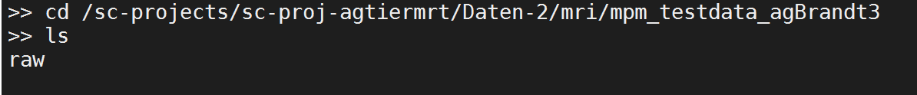

You can see that the project-folder contains a single folder 'raw', which contains the Bruker-raw data.

**9) Create an ANTx project-file**

Execute the following command

**makeproject('projectname',fullfile(pwd,'proj.m'), 'voxsize',[.07 .07 .07],'wa_refpath','/sc-projects/sc-proj-agtiermrt/Daten-2/ressources/anttemplates/mouse_Allen2017HikishimaLR','wa_species','mouse');**

-This command creates a project-file '**proj.m**' with defined target voxel size of 0.07 x 0.07 x 0.07 mm, the **animal template** is '**mouse_Allen2017HikishimaLR**', and the species is **'mouse'**.

NOTE: A suitable template can be downloaded from google-drive : <https://drive.google.com/drive/folders/1q5XOOVLvUYLqYsQJLqNRF7OK8fNwYhI9>

The template should be unzipped and stored where it could be reached (do not save the downloaded template in the current project-folder!).

**Creating a project-file has to be done only once!**

Aside the project-file '**proj.m**' an empty 'dat'-folder is created



**10) Load the project-file 'proj.m'**

Here we load the created project-file **'proj.m':**

loadconfig(fullfile(pwd,'proj.m'));

**11) Check whether the project-file loaded**

global an;

an

The global variable 'an' (struct) contains the basic information for this study. In the CMD-window you should the following:

project: 'NEW PROJECT'

datpath: '/sc-projects/sc-proj-agtiermrt/Daten-2/mri/mpm_testdata_agBrandt3/dat'

voxsize: [0.0700 0.0700 0.0700]

wa: [1x1 struct]

**12) Import BRUKER-data**

Before doing this step, I just created the 'raw'-folder within the study's folder and copied the datasets of two animals into the '**raw'**-folder. First we just read the file-information of the Bruker raw-data from the 'raw'- folder (fullfile(pwd,'raw')) which is located in the current study folder.

The file-information will be stored in the resulting w-struct.

w=xbruker2nifti(fullfile(pwd,'raw'),0,[],[],'gui',0,'show',1); % first read all data and show it

The w-struct contains the file-information table 'd' with header 'hd'. This table is listed in the CMD-window when running this command. You could save & reload the struct and import some data later on (advantage: loading time is reduced). To show the table again just type:

w.showtable(w) ; %to show the table in CMD-window

If graphic is supported you could also visualize the table in an extra window via w.showtable2(w) .

Here, the raw-data folder contains two data-sets (i.e. the data from two animals):

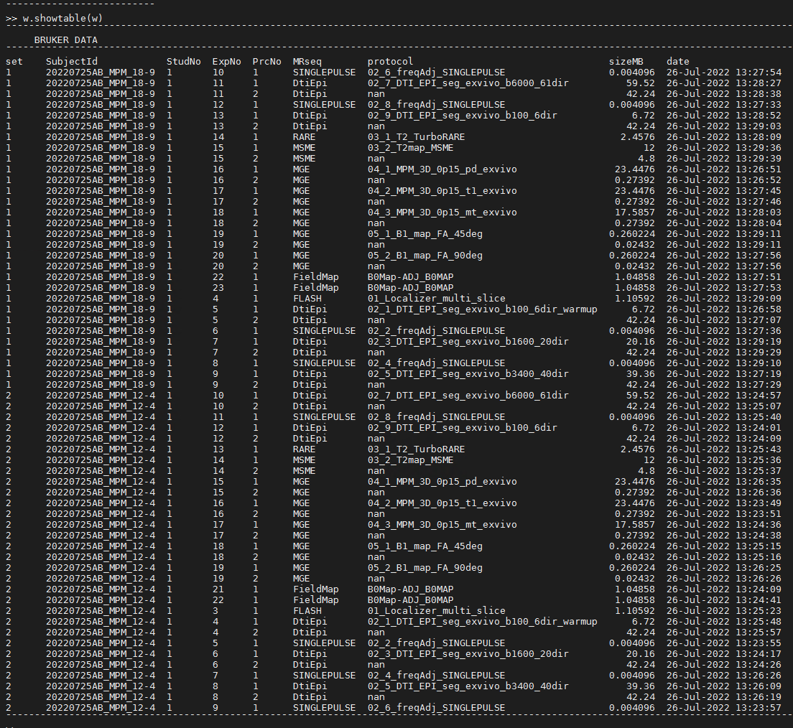

Here we want to import the following files:

**03_1_T2_TurboRARE**

**04_1_MPM_3D_0p15_pd_exvivo**

**04_2_MPM_3D_0p15_t1_exvivo**

**04_3_MPM_3D_0p15_mt_exvivo**

To **visualize** the filtered table run the following command (note that the w-struct is used as 1st argument):

w2=xbruker2nifti(w,0,[],[],'gui',0,'show',1,'flt',{'pro','**03_1_T2_TurboRARE|04_1_MPM_3D_0p15_pd_exvivo|04_2_MPM_3D_0p15_t1_exvivo|04_3_MPM_3D_0p15_mt_exvivo**' } );

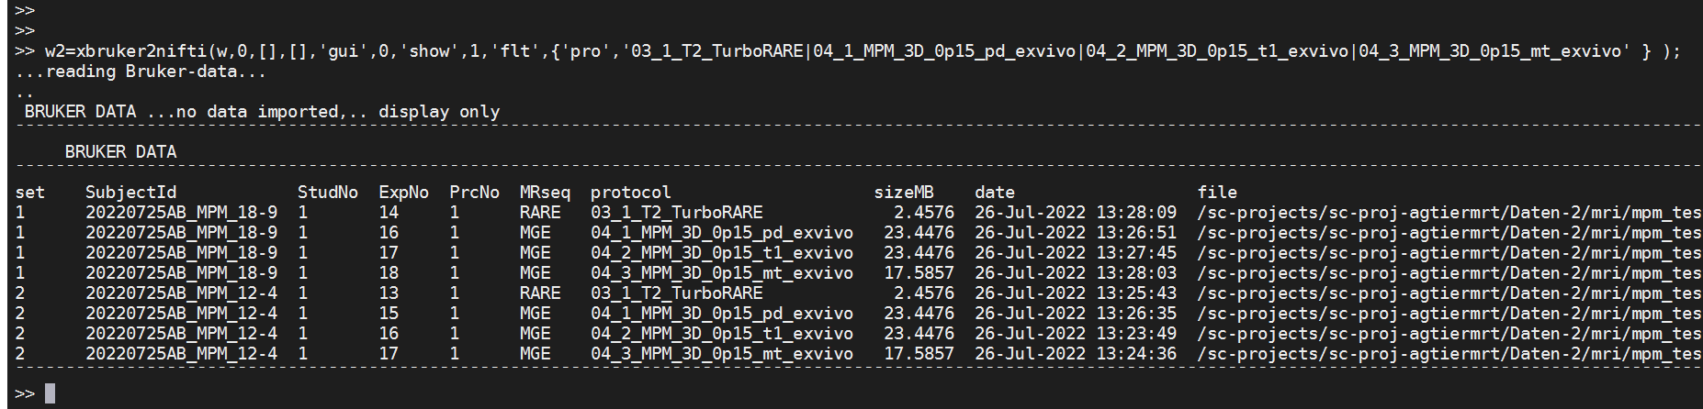

Now let's import these data. For this just set the 'show'-parameter to 0:

w2=xbruker2nifti(w,0,[],[],'gui',0,'show',**0**,'flt',{'pro','**03_1_T2_TurboRARE|04_1_MPM_3D_0p15_pd_exvivo|04_2_MPM_3D_0p15_t1_exvivo|04_3_MPM_3D_0p15_mt_exvivo**' } );

**13) Visualize files and folders**

-type **dispfiles** to see a file-by-folder matrix in the command-window (see dispfiles for further help):

dispfiles

The following is displayed in the CMD-window:

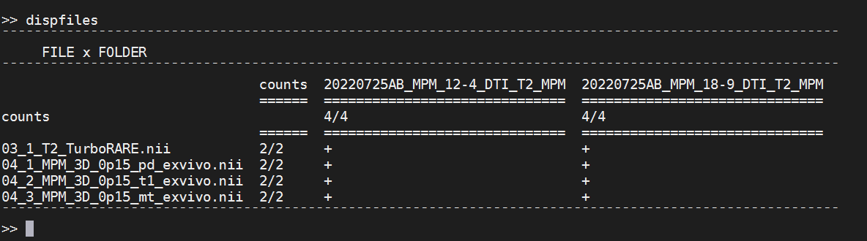

Here we see that the study's '**dat'**-folder now contains two animal-folders ('**20220725AB_MPM_12-4_DTI_T2_MPM**' and '**20220725AB_MPM_18-9_DTI_T2_MPM**'). Each Folder contains the imported files **('03_1_T2_TurboRARE.nii', '04_1_MPM_3D_0p15_pd_exvivo.nii', '04_2_MPM_3D_0p15_t1_exvivo.nii' and '04_3_MPM_3D_0p15_mt_exvivo.nii')**

**14) Selection of animals (not needed now, but later)**

This is a way to simple obtain the animal-directories

For example: to obtain **all** animal-folders from the 'dat'-folder:

mdirs=antcb('getallsubjects')

Note that the variable '**mdirs**' contains the full paths names of the selected animals:

>> mdirs=antcb('getallsubjects')

mdirs =

2x1 cell array

{'/sc-projects/sc-proj-agtiermrt/Daten-2/mri/mpm_testdata_agBrandt3/dat/20220725AB_MPM_12-4_DTI_T2_MPM'}

{'/sc-projects/sc-proj-agtiermrt/Daten-2/mri/mpm_testdata_agBrandt3/dat/20220725AB_MPM_18-9_DTI_T2_MPM'}

>>Alternative selection of all animals:

mdirs =antcb('selectdirs',[1:2 ]) ;% obtain path of the first two animals

mdirs =antcb('selectdirs',[1 ]) ;% obtain path of the 1st animal

mdirs =antcb('selectdirs',[2 ]) ;% obtain path of the 2nd animal

mdirs=antcb('selectdirs','all') ; % obtain path of all animals

**15) Modify the ANTx-project-file**

We have to modify the project-file **'proj.m'** because:

1) The 1st volume of **'04_2_MPM_3D_0p15_t1_exvivo.nii'** is used for registration to standard space (i.e. to the template 'mouse_Allen2017HikishimaLR'). You can see that the orientation is different compared to the template ('AVGT.nii')

|  |  |
| --- | --- |
| The 1st volume of **'04_2_MPM_3D_0p15_t1_exvivo.nii'** | **'AVGT.nii' of**  **'mouse_Allen2017HikishimaLR'** |

I.e. a proper initial re-Orientation is need:

For this, we have to set the '**orientType**' in the project-file to **[11]**

**x.wa.orientType = [11] ; % index from the reorientation Table**

To obtain the pre-orientation see section **'MISC-2: get pre-orientation from standard-space to T1/MT/PD'** below.

Also we see that the brain is skullstripped and embedded in Fomblin (exVivo-approach). Therefore we have to change the parameter **'usePriorskullstrip' to [6]** (otherwise use [1])

**x.wa.usePriorskullstrip = [6] ;% use a priori skullstripping (used for automatic registration)**

You have to set these two parameters manually in the proj.m-file

When done, the proj.m-file looks as follows:

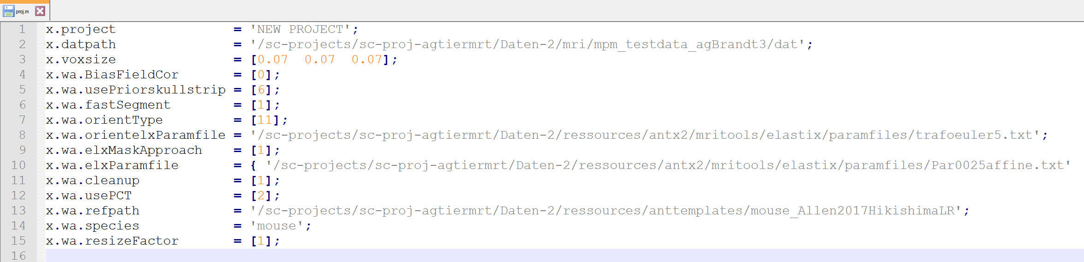

We have to re-load the project-file **'proj.m':**

loadconfig(fullfile(pwd,'proj.m'));

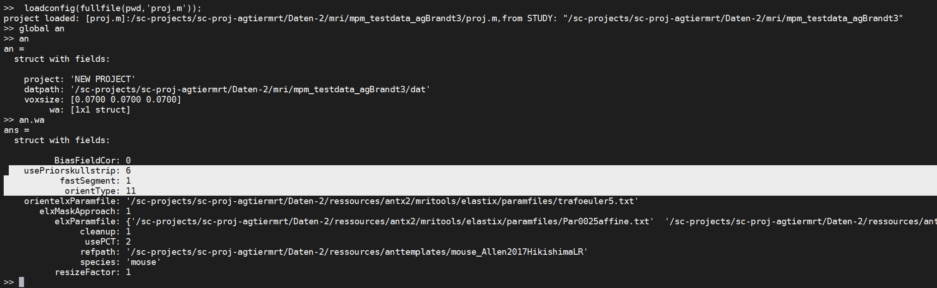

**16) Set path of mpm_rodent-toolbox**

Execute the following commands

pa_wd=pwd; %get study-path (current path)

cd /sc-projects/sc-proj-agtiermrt/Daten-2/ressources/mpm_rodent; % go to path of mpm-wrapper-functions

mpmlink ; %link path of mpm-wrapper-functions

cd(pa_wd); %go back to study-path

**17) Create 'mpm'-dir & copy necessary files**

Now we need to create a subfolder **'mpm'** in the study's folder and copies of three files from the mpm-rodent-tbx:

**'mpm_NIFTIparameters.xlsx'**

**'mpm_config.m'**

**'hmri_local_defaults_mouse.m'**

To create the 'mpm'-folder in the study-directory and copy these three files execute the following command. (**Important**: the current folder must be the study-folder):

f_setup('ini')

We can see that the mpm-folder with the three files was created:

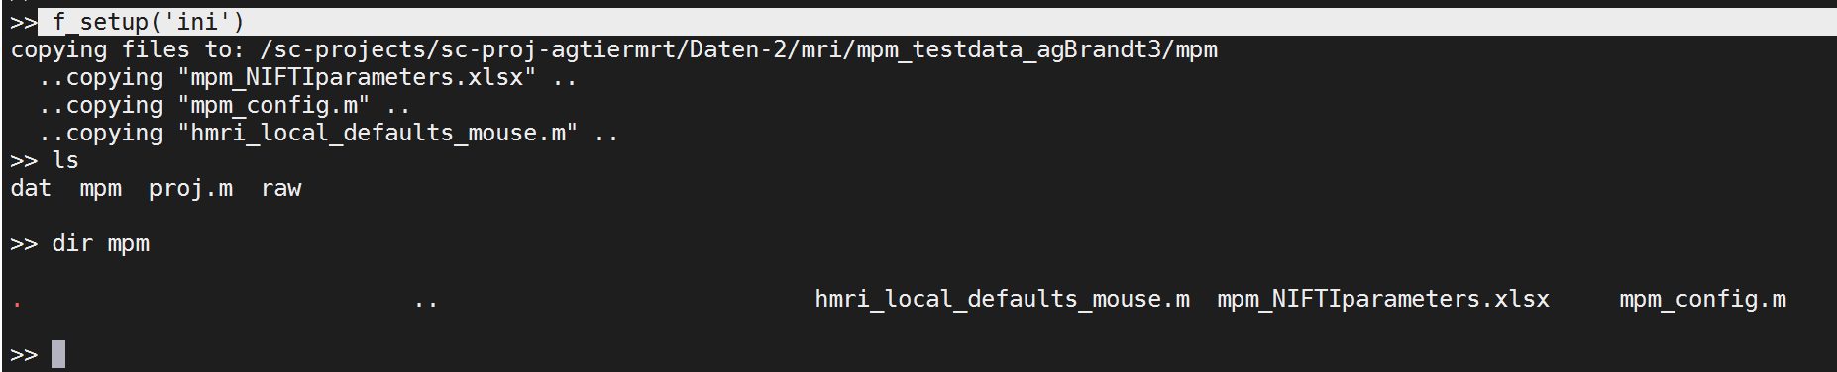

**18) Modify 'mpm_NIFTIparameters.xlsx'**

Now, we have to modify the Excel-file '**mpm_NIFTIparameters.xlsx**' manually.

Note that this file is located in the study's mpm-folder.

Specifically, we have to add the input-NIFTI-filenames (**'03_1_T2_TurboRARE.nii', '04_1_MPM_3D_0p15_pd_exvivo.nii', '04_2_MPM_3D_0p15_t1_exvivo.nii' and '04_3_MPM_3D_0p15_mt_exvivo.nii'**) in the proper row of column-2.

(See fig below). When done, save excel file.

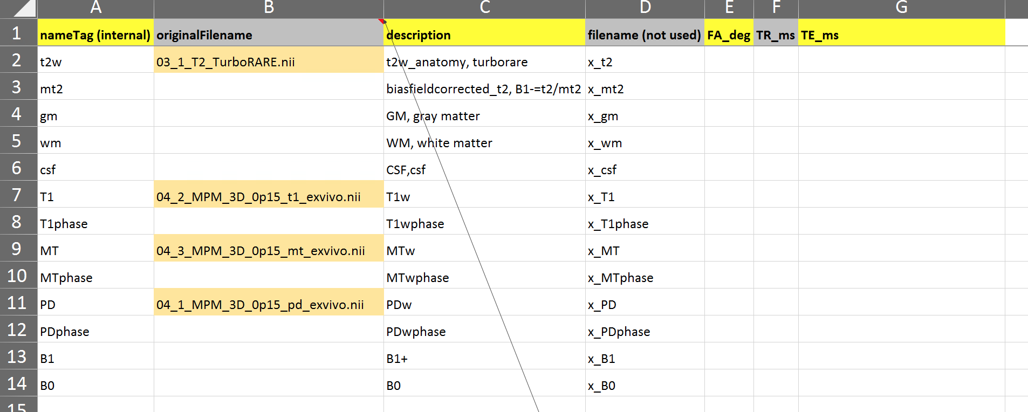

**19) Modify 'mpm_config.m'**

We next have to modify the file 'mpm_config.m' (Note that this file is located in the study's mpm-folder):

1) We have to set the path of the hmri-toolbox in the variable **'mpm.MPM_path'**

Here, I set the path as follows:

mpm.MPM_path ='/sc-projects/sc-proj-agtiermrt/Daten-2/ressources/hMRI-toolbox-0.2.4'

2) Here we use the SPM-version from the ANTx2-toolbox. Therefore, the variable **'mpm.SPM_path'** must me empty (''):

mpm.SPM_path ='' ;%SPM-toolbox path

3) The field **'mpm.t2w_preorient'** has to be set. This variable defines the difference in orientation from the turborare-image (t2w) to the **'04_2_MPM_3D_0p15_t1_exvivo.nii'-image** (T1). Later, the turborare-image will be registered to the T1/PD/MT-images. For this, a proper reorientation is needed. Here the reorientation is **[1.5708 0 1.5708]**

Thus the following is set:

mpm.t2w_preorient=[1.5708 0 1.5708]; % preorientation (rotations) of turborare (t2) to match orientation with PD/T1/MT-images

To obtain the pre-orientation see section **'MISC-3: get pre-orientation from t2w to T1/MT/PD'** below

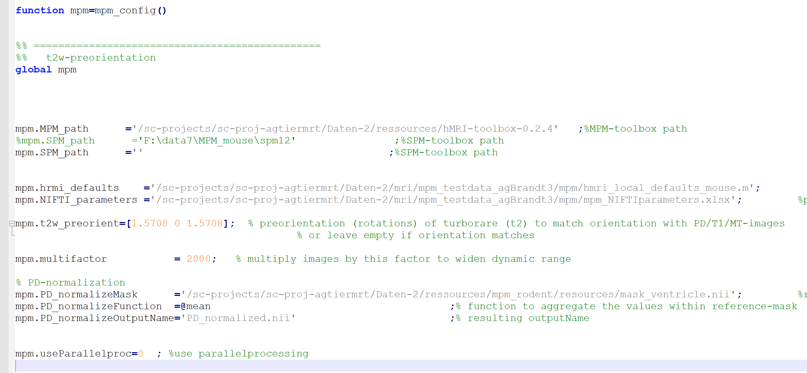

When done, save file.

**20) Run all processing steps (interactive session)**

**Execute the following commands to run all processing steps**

Run all processing steps (interactive mode)

mpm('steps'); %display processing steps,functions and numeric indicators

cd /sc-projects/sc-proj-agtiermrt/Daten-2/mri/mpm_testdata_agBrandt3

loadconfig(fullfile(pwd,'proj.m')); %load ANTX-project of current study

v=struct();

v.mpm_configfile = fullfile(pwd,'mpm','mpm_config.m' ); % mpm-configfile

v.antx_configfile = fullfile(pwd,'proj.m' ); % antx-projectfile(configfile)

v.pstep = 'all' ;%preprocessing steps,'all' or use indices([1:5]; see mpm('steps')

v.hstep = 'all' ;%hmri-processing steps,'all' or use indices([1:5]; see mpm('steps');

v.mdirs=antcb('getallsubjects') ; % path of animals-DIRs to process

%or hardcode animals to process

%v.mdirs={?

%'/sc-projects/sc-proj-agtiermrt/Daten-2/mri/mpm_testdata_agBrandt3/dat/20220725AB_MPM_12-4_DTI_T2_MPM'

%'/sc-projects/sc-proj-agtiermrt/Daten-2/mri/mpm_testdata_agBrandt3/dat/20220725AB_MPM_18-9_DTI_T2_MPM'

%}

mpm('nogui',v) ; % run proccessing steps without GUI

**21) SLURM SBATCH & non-interactive session**

Using a bash-starterfile (*.sh) and an additional matlab-script we can run all steps via the SLURM **sbatch** command.

**1) Matlab-starterScript**

First, we need a matlab-script, here named 'runHPC_main.m', which is located in the study's folder

The file '**runHPC_main.m**' looks as follows:

disp('***STARTERSCRIPT: MPM on HPC ***')

disp(['path' pwd]);

%% ======================================

%% *** LINK ANTx-PATHs *******************

%% ======================================

disp('LINK ANTx-PATHs');

cd /sc-projects/sc-proj-agtiermrt/Daten-2/ressources/antx2/ %go to ANTx-path

antlink ; %link path of antx2

disp(['PATH-ANTx2:' which('ant.m') ]);

%% ======================================

%% *** LINK mpm-wrapper-functions-PATHs ***

%% ======================================

disp('LINK mpm-wrapper-functions-PATHs');

cd /sc-projects/sc-proj-agtiermrt/Daten-2/ressources/mpm_rodent; % go to path of mpm-wrapper-functions

mpmlink ; %link path of mpm-wrapper-functions

disp(['PATH-mpmWF:' which('mpm.m') ]);

if 1

timex=tic ;% capture START-TIME

cd /sc-projects/sc-proj-agtiermrt/Daten-2/mri/mpm_testdata_agBrandt3 % go to current study

loadconfig(fullfile(pwd,'proj.m')); %load ANTX-project of current study

v=struct();

v.mpm_configfile = fullfile(pwd,'mpm','mpm_config.m' ); % mpm-configfile

v.antx_configfile = fullfile(pwd,'proj.m' ); % antx-projectfile(configfile)

v.pstep = 'all' ;%preprocessing steps,'all' or use indices([1:5]; see mpm('steps')

v.hstep = 'all' ;%hmri-processing steps,'all' or use indices([1:5]; see mpm('steps');

v.mdirs=antcb('getallsubjects') ; % path of animals-DIRs to process

%or hardcode animals to process

%v.mdirs={â€¦

%'/sc-projects/sc-proj-agtiermrt/Daten-2/mri/mpm_testdata_agBrandt3/dat/20220725AB_MPM_12-4_DTI_T2_MPM'

%'/sc-projects/sc-proj-agtiermrt/Daten-2/mri/mpm_testdata_agBrandt3/dat/20220725AB_MPM_18-9_DTI_T2_MPM'

%}

mpm('nogui',v) ; % run proccessing steps without GUI

disp(sprintf('FINISHED: ET=%2.2fh',toc(timex)/(60*60))); %DISPLAY ELAPSED TIME

end

exit; %iMPORTANT, otherwise HPC would run until time-out

**2) starter-shellscript**

We also need a shellscript (here named **'batch_MPM_agbrandt.sh'**) which is located in the HPC user's workspace. The shellscript does the following jobs: set HPC parameters, go to the study's folder and run the '**runHPC_main.m**' file via Matlab

#!/bin/bash

#SBATCH --job-name=mpm #Specify job name

#SBATCH --output=mpm.o #FileName of output with %A(jobID) and %a(array-index);(alternative: .o%j) output=mpm.o%A_%a

#SBATCH --error=mpm.e #FileName of error with %A(jobID) and %a(array-index);alternative: .e%j) error=mpm.e%A_%a

#SBATCH --partition=compute # Specify partition name

#SBATCH --nodes=1 # Specify number of nodes

#SBATCH --cpus-per-task=50 # Specify number of CPUs (cores) per task

#SBATCH --time=48:00:00 # Set a limit on the total run time; example: 22:00:00(22hours) or 7-00(7days)

#SBATCH --array=1 # Specify array elements (indices), i.e. indices of of parallel processed dataSets

module load scientific/matlab/R2021b

#matlab

#matlab -nodisplay -r "./my_simulation ; exit"

#source: https://arc.umich.edu/software/matlab/#:~:text=To%20run%20a%20MATLAB%20script,m%20from%20the%20current%20directory.&text=Note%20that%20the%20MATLAB%20script,an%20exit%20command%20in%20it.

cd /sc-projects/sc-proj-agtiermrt/Daten-2/mri/mpm_testdata_agBrandt3

matlab -r runHPC_main

**3) run via sbatch-command**

We can finally run the shellscript via the sbatch command from the HPC-front-Node

sbatch **batch_MPM_agbrandt.sh**



To check the progress/error/output you can use the following commands

squeue –me 🡪 check whether job is pending/running or finished

cat mpm.o 🡪 to check output

cat mpm.e 🡪 to check errors

**22) SLURM SBATCH & parallel processing**

We can slightly change the bash-starterfile and the Matlab file from the previous section and let the animals run in parallel. Using a bash-starterfile (*.sh) and an additional matlab-function we can run all steps via the SLURM **sbatch** command. Instead of a Matlab-starterScript we use a **Matlab**-**function** and use the SLURM-array-ID as first input-argument. The SLURM-array-ID works as 'parallelizer' and is used to assigns the respective animal.

**1) Matlab-starterFunction (parallel processing)**

First, we need a matlab-Function(**'runHPC_main_parallel.m'**), which is located in the study's folder.

Important: The 1st input argument (animalNo) is the SLURM-array-ID (transferred from the shellscript). AnimalNo is a numeric value and can be 1 or 2 because we have two animals (this is defined in the shellscript: see line with '#SBATCH --array=1-2').

The file **'runHPC_main_parallel.m'** looks as follows:

function runHPC_main_parallel(animalNo)

disp('***STARTERSCRIPT: MPM on HPC ***')

disp(['path' pwd]);

%% ======================================

%% *** LINK ANTx-PATHs *******************

%% ======================================

disp('LINK ANTx-PATHs');

cd /sc-projects/sc-proj-agtiermrt/Daten-2/ressources/antx2/ %go to ANTx-path

antlink ; %link path of antx2

disp(['PATH-ANTx2:' which('ant.m') ]);

%% ======================================

%% *** LINK mpm-wrapper-functions-PATHs ***

%% ======================================

disp('LINK mpm-wrapper-functions-PATHs');

cd /sc-projects/sc-proj-agtiermrt/Daten-2/ressources/mpm_rodent; % go to path of mpm-wrapper-functions

mpmlink ; %link path of mpm-wrapper-functions

disp(['PATH-mpmWF:' which('mpm.m') ]);

if 1

timex=tic ;% capture START-TIME

cd /sc-projects/sc-proj-agtiermrt/Daten-2/mri/mpm_testdata_agBrandt3 % go to current study

loadconfig(fullfile(pwd,'proj.m')); %load ANTX-project of current study

v=struct();

v.mpm_configfile = fullfile(pwd,'mpm','mpm_config.m' ); % mpm-configfile

v.antx_configfile = fullfile(pwd,'proj.m' ); % antx-projectfile(configfile)

v.pstep = 'all' ;%preprocessing steps,'all' or use indices([1:5]; see mpm('steps')

v.hstep = 'all' ;%hmri-processing steps,'all' or use indices([1:5]; see mpm('steps');

mdirs=antcb('getallsubjects') ; % path of animals-DIRs to process

v.mdirs=mdirs(animalNo); %select animal via SLURM-job-array-index

disp(['executing: running animal: ' char(v.mdirs) ]);

mpm('nogui',v) ; % run proccessing steps without GUI

disp(sprintf('FINISHED: ET=%2.2fh',toc(timex)/(60*60))); %DISPLAY ELAPSED TIME

end

exit; %iMPORTANT, otherwise HPC would run until time-out

**2) starter-shellscript (parallel processing)**

We also need a shellscript (here named '**batch_MPM_parallel_agbrandt.sh'**) which is located in the HPC user's workspace. The shellscript does the following jobs: set HPC parameters, go to the study's folder and run the **'runHPC_main_parallel.m'** file via Matlab.

The difference to the previous session is that that the animals will be processed at the same time.

Important lines are:

|  |  |
| --- | --- |
| output=mpmPP.o%A_%a  error=mpmPP.e%A_%a | The output/error-Filename is created via:  "mpmPP"+"o"/"e"+"jobID"+" arrayIndex"  For example:  The output-LOG-files of the two animals will be:  'mpmPP.o1662013_1' & 'mpmPP.o1662013_2'  The error-LOG-files of the two animals will be:  'mpmPP.e1662013_1' & 'mpmPP.e1662013_2' |
| #SBATCH --array=1-2 | Here we specify the number of array elements—in our case dataSets  Because we have two animals the command is: #SBATCH --array=1-2 |
| matlab -r "runHPC_main_parallel($SLURM_ARRAY_TASK_ID)" | The function 'runHPC_main_parallel' is started via Matlab and the variable $SLURM_ARRAY_TASK_ID is used as 1st input-argument  -$SLURM_ARRAY_TASK_ID is a numeric value and can be only 1 or 2 because of: "SBATCH --array=1-2" "  -quotes are required to keep the parentheses from being interpreted |

The file '**batch_MPM_parallel_agbrandt.sh'** looks as follows:

#!/bin/bash

#SBATCH --job-name=mpmPP #Specify job name

#SBATCH --output=mpmPP.o%A_%a #FileName of output with %A(jobID) and %a(array-index);(alternative: .o%j) output=mpm.o%A_%a

#SBATCH --error=mpmPP.e%A_%a #FileName of error with %A(jobID) and %a(array-index);alternative: .e%j) error=mpm.e%A_%a

#SBATCH --partition=compute # Specify partition name

#SBATCH --nodes=1 # Specify number of nodes

#SBATCH --cpus-per-task=50 # Specify number of CPUs (cores) per task

#SBATCH --time=48:00:00 # Set a limit on the total run time; example: 22:00:00(22hours) or 7-00(7days)

#SBATCH --array=1-2 # Specify array elements (indices), i.e. indices of of parallel processed dataSets

module load scientific/matlab/R2021b

cd /sc-projects/sc-proj-agtiermrt/Daten-2/mri/mpm_testdata_agBrandt3

matlab -r "runHPC_main_parallel($SLURM_ARRAY_TASK_ID)" # quotes are required to keep the parentheses from being interpreted by the shell

**3) run sbatch-command (parallel processing)**

We can finally run the shellscript via the sbatch command from the HPC-front-Node

sbatch **batch_MPM_parallel_agbrandt.sh**

**MISC-1: Other command snips**

**Start interactive session & start Matlab, link path of antx2 and mpm-rodent, go to studyfolder,**

srun --time 24:00:00 --mem=64G --ntasks=8 --pty bash -i

module load scientific/matlab/R2021b

matlab

cd /sc-projects/sc-proj-agtiermrt/Daten-2/mri/mpm_testdata_agBrandt3

pa_wd=pwd ; % get study-path (current path)

cd /sc-projects/sc-proj-agtiermrt/Daten-2/ressources/antx2/ %go to ANTx-path

antlink ; %link path of antx2

cd /sc-projects/sc-proj-agtiermrt/Daten-2/ressources/mpm_rodent; % go to path of mpm-wrapper-functions

mpmlink ; %link path of mpm-wrapper-functions

cd(pa_wd); % go back to study-path

**%------UPDATE ANTx and mpm-rodent TOOLBOXES**

pa_wd=pwd ; % get study-path (current path)

cd /sc-projects/sc-proj-agtiermrt/Daten-2/ressources/antx2/ %go to ANTx-path

updateantx(3)

cd /sc-projects/sc-proj-agtiermrt/Daten-2/ressources/mpm_rodent; % go to path of mpm-wrapper-functions

updatempm(3)

cd(pa_wd); % go back to study-path

**%------start: interactive session, add Paths, load study's projectfile**

srun --time 24:00:00 --mem=64G --ntasks=8 --pty bash -i

module load scientific/matlab/R2021b

matlab

cd /sc-projects/sc-proj-agtiermrt/Daten-2/ressources/antx2/ %go to ANTx-path

antlink ; %link path of antx2

cd /sc-projects/sc-proj-agtiermrt/Daten-2/ressources/mpm_rodent; % go to path of mpm-wrapper-functions

mpmlink ; %link path of mpm-wrapper-functions

cd /sc-projects/sc-proj-agtiermrt/Daten-2/mri/mpm_testdata_agBrandt3

loadconfig(fullfile(pwd,'proj.m')); %load ANTX-project of current study

**MISC-2: get pre-orientation from standard-space to T1/MT/PD-space**

The below figure shows that the T1/PD/MT-images are differently oriented compared to the standard-space ('AVGT.nii' from 'mouse_Allen2017HikishimaLR'.

|  |  |
| --- | --- |
| The 1st volume of  **'04_2_MPM_3D_0p15_t1_exvivo.nii'** | **'AVGT.nii' of**  **'mouse_Allen2017HikishimaLR'** |

Thus, we need a rough pre-orientation from standard space to T1/MT/PD-space. Here we obtain the pre-orientation manually via GUI. It might be necessary to use another machine, because it's possible your HPC-cluster might not have graphical support.

**Note, these steps need to be done only once per study!**

**1) Necessary preliminary steps**

-Paths of ANTx and mpm-rodent are set in Matlab

-go to study-folder. Here I use another machine: cd F:\data8_MPM\MPM_agBrandt3

-open ANTx-GUI: ant

load projectfile: use button [loadproj] from ANTx-GUI ore type: antcb('load','proj.m')

select the 1st animal from the left animal-listbox from ANTx-GUI

open mpm_rodent-GUI: mpm

load mpm_config file: use button [load config-file]. When successful, the config-file is displayed in the black info-bar.

|  |  |
| --- | --- |
| ANTx-GUI | Mpm_rodent-GUI |

**1) get pre-orientation from standard-space to T1/MT/PD**

|  |  |
| --- | --- |
| 1) From mpm-GUI select to MENU: Preproc/**estimate pre-orientation T1/PD/MT to template (AVGT.nii)** | 2) This will open a parameter-window. Make **no** changes, just hit [RUN] |
| 3) The new GUI (3-point-selection) will open. | 4) In the command-window the instruction is given:  **estimate pre-orientation: "04_2_MPM_3D_0p15_t1_exvivo.nii" to "F:\data8_MPM\MPM_agBrandt3\templates\AVGT.nii"**  **GET PREORIENTATION**  **1) change each image to CORONAL orientation [dim1],[dim2] or [dim3] button**  **2) set 3 landmarks in each volume**  **2.1) top(superior) of OLFACT. BULBUS**  **2.2) superior part of MIDLINE STRUCTURE**  **2.3) inferor part of MIDLINE STRUCTURE and onthe same plane as (2)**  **-ideally, the 3 points (a) anatomically match in both images**  **(b) must have a large large distance from each other**  **3) Select MRicron from pulldown and hit [check]-button to inspect the overlay.**  **-alternatively, just and hit [check]-button (without MRicron)**  **4) If the overlay is "ROUGHLY" OK, hit [CLOSE]-button.** |
| 5) First we set all images to coronal view by clicking on the[dim2] –button below each image | 6) Next, select the [**OB**]-radio and click onto the top/supperor part of the olfactory bulbus in each image. At the selected location a red dot will appear. You can reset the dot by clicking another location of the image. A rough setting is enough, don't be to precise |
| 7) Next, select the [**SUP**]-radio and click onto the superior part of a MIDLINE STRUCTURE in each image. At the selected location a green dot will appear. | 8) Next, select the [**INF**]-radio and click onto the inferior part of a MIDLINE STRUCTURE on the **same plane** as used in the  previous step. Do this for each image. At the selected location a blue dot will appear. |
| 9) Important: hit the [**check**]-button.  This will display the rotations and translations in the command line: here:  ROTATIONS: 3.1416 -1.2246e-16 1.5708  TRANSLATIONS: -18.2591 -0.107396 11.9797  This step also visualizes the orientation: | 10) You can also display the pre-orientation as overlay via MRicron. For this select [MRicron] from the pulldown-menu and hit the [**check**]-button. |
| 11) The pre-orientation looks ok. Hit the [**close**]-button from to close the window (3-point-selection-GUI) |  |
| 12) When done, the command line will display the following: | |
| 12) Here we want to change pre-orientation by setting the variable "orientType" to [**11**]  Alternatively, "orientType" can also set to **'3.142 -0 1.571'.**  For this, hit the hit the [gear]-icon from the ANTx-GUI to  open the parameter setting |  |
| In the parameter file change "orientType" to [11], as shown below.  Hit [OK]-button | |
| 13) reload ANT-project-file  Use type :  antcb('reload') or antcb('load','proj.m')  or manually load the proj-file via [loadproj]-button |  |
|  |  |

**MISC-3: get pre-orientation from t2w-space to T1/MT/PD-space**

The below figure shows that the T1/PD/MT-images are differently oriented compared to the t2w-image (**'03_1_T2_TurboRARE.nii')**.

|  |  |
| --- | --- |
| The 1st volume of  **'04_2_MPM_3D_0p15_t1_exvivo.nii'** | **The t2w-image '03_1_T2_TurboRARE.nii' from the same animal** |

Thus, we need a rough **pre-orientation from t2w-space to T1/MT/PD-space**. Here we obtain the pre-orientation manually via GUI. It might be necessary to use another machine, because it's possible your HPC-cluster might not have graphical support.

**Note, these steps need to be done only once per study!**

**1) Necessary preliminary steps**

-Paths of ANTx and mpm-rodent are set in Matlab

-go to study-folder. Here I use another machine: cd F:\data8_MPM\MPM_agBrandt3

-open ANTx-GUI: ant

load projectfile: use button [loadproj] from ANTx-GUI ore type: antcb('load','proj.m')

select the 1st animal from the left animal-listbox from ANTx-GUI

open mpm_rodent-GUI: mpm

load mpm_config file: use button [load config-file]. When successful, the config-file is displayed in the black info-bar.

|  |  |
| --- | --- |
| ANTx-GUI | Mpm_rodent-GUI |

**1) get pre-orientation from t2w to T1/MT/PD**

|  |  |
| --- | --- |
| 1) From mpm-GUI select to MENU: Preproc/**estimate pre-orientation T1/PD/MT to template (AVGT.nii)** | 2) This will open a parameter-window. Make **no** changes, just hit [RUN] |
| 3) The new GUI (3-point-selection) will open. | 4) In the command-window the instruction is given:  **estimate pre-orientation: "t2w.nii" to "t1.nii"**  **GET PREORIENTATION**  **1) change each image to CORONAL orientation [dim1],[dim2] or [dim3] button**  **2) set 3 landmarks in each volume**  **2.1) top(superior) of OLFACT. BULBUS**  **2.2) superior part of MIDLINE STRUCTURE**  **2.3) inferor part of MIDLINE STRUCTURE and onthe same plane as (2)**  **-ideally, the 3 points (a) anatomically match in both images**  **(b) must have a large large distance from each other**  **3) Select MRicron from pulldown and hit [check]-button to inspect the overlay.**  **-alternatively, just and hit [check]-button (without MRicron)**  **4) If the overlay is "ROUGHLY" OK, hit [CLOSE]-button.** |
| 5) First we set all images to coronal view by clicking on the [dim2] –button on the 2nd image. Note that the 1st image is already in coronar view | 6) Next, select the [**OB**]-radio and click onto the top/superior part of the olfactory bulbus in each image. At the selected location a red dot will appear. You can reset the dot by clicking another location of the image. A rough setting is enough, don't be to precise |
| 7) Next, select the [**SUP**]-radio and click onto the superior part of a MIDLINE STRUCTURE in each image. At the selected location a green dot will appear. | 8) Next, select the [**INF**]-radio and click onto the inferior part of a MIDLINE STRUCTURE on the **same plane** as used in the  previous step. Do this for each image. At the selected location a blue dot will appear. |
| 9) Important: hit the [**check**]-button.  This will display the rotations and translations in the command line: here:  ROTATIONS: 1.5708 -6.1232e-17 1.5708  TRANSLATIONS: 0.0828656 -18.15 17.7361  This step also visualizes the orientation: | 10) You can also display the pre-orientation as overlay via MRicron. For this select [MRicron] from the pulldown-menu and hit the [**check**]-button. |
| 11) The pre-orientation looks ok. Hit the [**close**]-button from to close the window (3-point-selection-GUI) |  |
| 12) When done, the command line will display the following: | |
| 12) Here we want to change pre-orientation of the t2w-image by editing the **[mpm_config.m]-**file in the **mpm**-folder.  …open '**mpm_config.m**'-file by clicking the hyperlink in the cmd-window |  |
| In the parameter file change "orientType" to [11], as shown below.  Hit [OK]-button | |
| 13) reload mpm  type :  mpm('reload')  or manually load the **[mpm_config.m]-**file via [load config-file]-button from mpm-GUI |  |